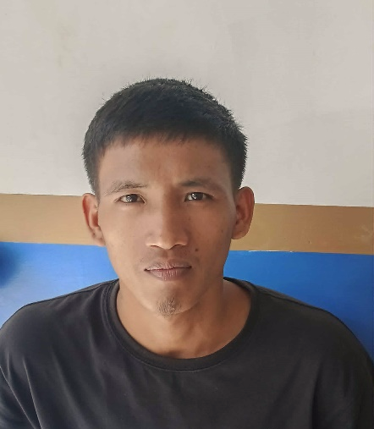

PERSONAL DATA

AGE : 25 yrs. old
DATE OF BIRTH : Feb 11, 2000
PLACE OF BIRTH : Masbate
NATIONALITY : Filipino
CIVIL STATUS : Single
RELIGION : Roman Catholic
HEIGHT : 5’5”
WEIGHT : 52kgs

EDUCATIONAL BACKGROUND

SECONDARY:

Godofredo Reyes Senior High School
- Cam Sur
2022-2023
PRIMARY:

Salvasion Elementary
- Cam Sur
2011-2012
SKILLS/TRAITS

- Basic skills in simple menu and some menu related previous experience department.
- Knowledgeable in table Cleaning
- Ability to work cooperatively with others and Initiative to improve self and service.

LEONIL, LORENO HANDIG
Poblacion, Baleno, Masbate
Contact No.: 09196423932
Email address: Handigleonil7@yahoo.com

CAREER OBJECTIVE

Seeking a company where I can utilize my full potential, expertise and knowledge in Kitchen Cook and Service Crew field with opportunity for growth and advancement in technical facets and profession.

TRAININGS AND CONFERENCE/SEMINARS ATTENDED

Primos Diner
Manila,
Work: Kitchen crew
March 25 – November 07, 2025

7/11 Store
Cashier
January-March 25, 2025

Chowking
Service Crew
November-January 24, 2025

CHARACTER REFERENCES

Jomari C. Cortes
Audit/Sales Manager-Solane LPG Masbate
F. Magallenes, Diversion Masbate City.
09319928711

Jomary Bagalay
Resident of Pob. Baleno Masbate.
09196423932

I hereby certify that the above information are true and correct to the best of my knowledge and belief.

Leonil Loreno Handig
Applicant

